CREATE A FORM

TEAM ID: PNT2022TMID10050

Connecting nodes using node-red:

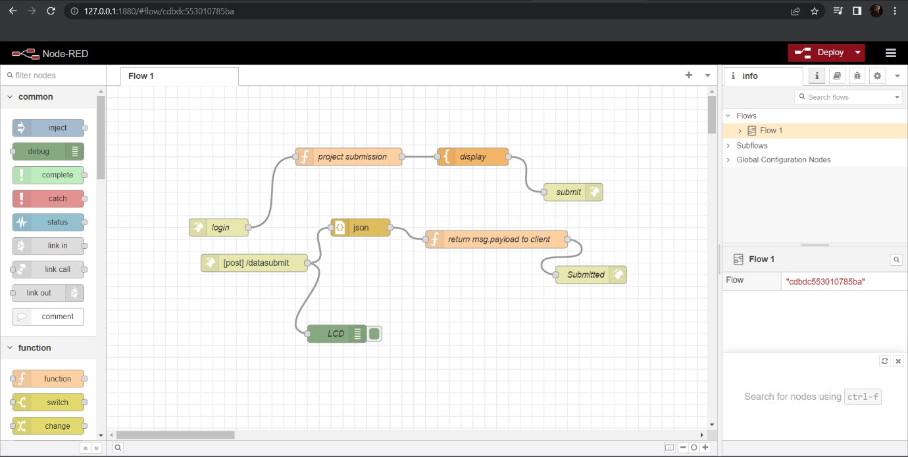

After deploying the nodes:

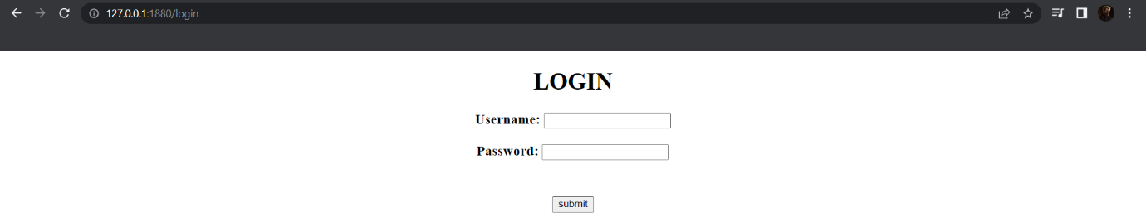

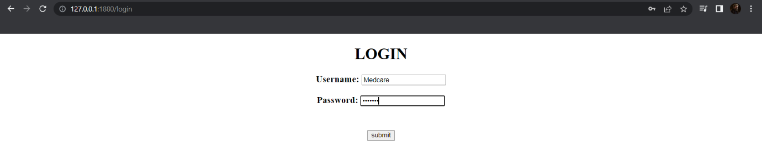

After clicking on Submit button:

